|  |
| --- |
| 新东方在线英语学习 |
| 新概念 1 册 |
| Lesson95-96 |



扫一扫。更多有趣的英语资讯。

# Lesson 95 单词讲解

1.return: n.往返

往返票 return tickets

单程票 single (journey) ticket zhe er ni

2.train: n.火车

1. platform: n.站台pu lai te
2. Platform 4
3. plenty: n.大量pu lan tei
4. plenty of
   1. 用于肯定句
   2. 可接可数名词& 不可数名词

plenty of time plenty of eggs

* 1. 谓语动词一致

There plenty of room for everyone. is

There plenty of rooms for everyone.are

1. bar: n.酒吧
2. station: n.车站，火车站train station
3. catch: v.赶上

catch- caught- caught 8.miss: v.错过

# Lesson 95 课文讲解

1. Two return tickets …, please.

n. + please

to, 开往… 表示方向

来三张去广州的往返票。

Three return tickets to Guangzhou.

来一张去西安的单程票。

One single ticket to Xi’an.

1. 下班火车几点出发？

What time…?

询问具点钟

1. 我们还有很多时间。

We have plenty of time. We’ve got plenty of time.

1. have a drink 喝一杯
2. next door to… 隔壁

公园的隔壁有家餐馆。

There is a restaurant next door to the park.

学校的隔壁有家医院。

There is a hospital next door to the school.

1. We had better go back to....

had better: 最好

1. We want to catch the eight nineteen…

the eight nineteen- the train leaves at 8:19

1. 那钟慢了 10 分钟。

That clock is ten minutes slow.

我的手表慢了 5 分钟。

My watch is five minutes slow.

那钟快了 5 分钟。

The clock is five minutes fast.

1. in+ 段时间, …之后

in five minutes 5 分钟之后

in two days 两天之后

in three years 三年之后

在 1 分钟之后的时间里：in one minute’s time 在 5 分钟之后的时间里：in five minutes’ time in two days’ time

in three years’ time

# Lesson 95 语法讲解

情态动词

must\ may\ can

A. 没有人称和单复数的变化

I can… You can… He can…

They can… We can…

B. + 动词原形

You can do it.

He can repair the car.

1. 疑问，提前

Can you repair it?

1. 否定，+ not

You can’t repair the car. had better 后面必须加动词

最好…用来提建议，但不是很客气

A. You had better… He had better… They had better…

B. + 动词原形

You had better give her a way out.

We had better come home before 6:00.

We had better wait for her.

1. 疑问，had 提前

Had you better give her a way out?

Had we better come home before 6:00? Had we better wait for her?

1. had better + not

You had better not give her a way out.

We had better not come home before 6:00. We had better not wait for her.

He has a bad cold.

1. He had better take some medicine.
2. He had better see the doctor.
3. He had better stay at home.
4. He had better drink some boiled water.

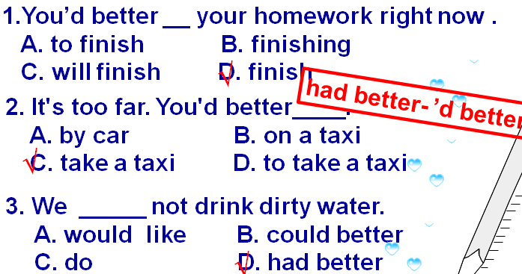

* You had better go to the Palace Museum this afternoon.

今下午你最好去故宫。

* You had better pay the money by the end of the month.

你月底前最好把钱付上。

-Have you ever been to…?

-Yes, I have.

-When did you go there?

-No, I haven’t.

-When will you go there?

提建议的方式：

1. You’d better…

You’d better stay in bed.

1. Why not + v. ?

Why not stay in bed?

1. advise sb. to do…ei de wa ai si

I advise you to stay in bed.

# Lesson 96 单词句型讲解

**Lesson 95&96 知识拓展**